Name(s)______________________Classroom Teacher__________
Belief System Assigned___________________________________________Library Skills 6

6th Grade Belief Systems Google Slides Project
Unit Learning Targets:
- I can conduct a research project by locating and recording relevant information from books and digital resources.
- I can organize my information by creating a Google Slides Presentation that informs the audience and is arranged in a logical and meaningful way
- I can locate and identify at least one Primary source and incorporate the information I gather from it into my research.
- I can list my sources using MLA style.

Ancient Civilizations
Many of the major belief systems have their origins in the ancient world and early Common Era.

Cultural Diffusion is the process by which cultural traits of one society directly or indirectly spread to the other society. Learning about belief systems will help you better understand how they impacted history and cultures around the world.

Major Belief Systems of the Modern World

You will research one of the major belief systems:
- Judaism  - Christianity  - Hinduism  - Islam  - Animism | - Buddhism  - Shinto  - Sikhism  - Confucianism  - Taoism

You will present your findings in a Google Slides Presentation of 8 slides. One group member creates the Google slides and then shares it with me and the other group members.
You will research these facts about the belief system:
- The central principle(s) of this belief system: monotheistic, polytheistic, animistic; basic core beliefs, commandments or truths
- The historical background and area of origin of the religion or belief system
- How and where the belief system spread (include map)
- Central figures (founders, key leaders, prophets)
- Sacred places (major places of worship, important cities, rivers, mountains)
- Sacred texts (books, epistles, writings)
- Symbols and their meanings
- Holidays, holy days, festivals and celebrations

Resources: Research using books from the Vernon Library and databases found on the Vernon Library Website (click on the “Student Projects” tab). (Username/Password: vernon / bulldogs)
- Use at least one PRIMARY SOURCE.
- Create a Works Cited page using MLA style citation.
Writing
(Individual Assignment):
In Google Classroom, there is a writing assignment to be completed after Google Slides portion of the project.
Read the following quote from the U.S. Constitution. Give your interpretation of the quote, the importance of it, and how it impacts our society.

Amendment I:
“Congress shall make no law respecting an establishment of religion, or prohibiting the free exercise thereof...”
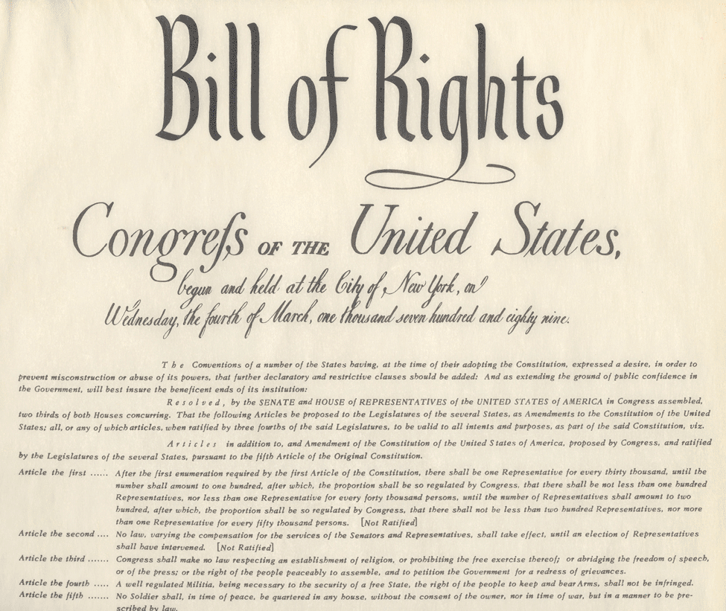

S-T-R-E-T-C-H YOUR VOCABULARY
Vocabulary Note: People from different regions of the world may have different religious practices and beliefs; they may also use different terms and have different pronunciations or spellings.
Cultural Diffusion — the process by which cultural traits of one society directly or indirectly spread to the other society.
Monotheism — Belief in one God.
Polytheism — Belief in many Gods.
Animists— People who believe entities in nature, such as animals, plants, and often even inanimate objects, possess a spiritual essence
Agnostics — People who believe the question of God’s existence is unanswerable.
Atheists — People who don’t believe in any God.
Karma — The Hindu and Buddhist belief that a person’s actions affect what happens to him or her.
Qur’an (Koran)— The holy writings of Islam.
Parables — Stories Christians believe were told by Jesus to teach a lesson.
Torah — The sacred writings of the Jewish religion.
(From “Understanding World Religions” Schlessinger Media, 2003)

Use the space below for your research. Use the information to create 3-5 sentence explanations (narratives) for slides #1 through #8.
Slide A is your Introduction slide. is your Introduction slide. It will be at the BEGINNING of your presentation. It should include:

Belief System:______________________________________
Your Names _______________________________________
_________________________________________________
Homeroom Teacher _________________________________
Picture, graphic, or photo that pertains to your topic.
Slide Z is your Bibliography slide. It will be at the BEGINNING of your presentation. It should include:
All books, databases, database and website articles, and videos you used in creating your presentation. It should be in MLA format. You may use Noodletools or EasyBib to create the citations.
You may use one video that is 3 minutes or less in your presentation.
PLAGIARISM: Any word-for-word copying (copy/paste or changing a few words) without quotation marks “” and citations (Smith 16) will result in a failing grade.

Slide 1 The central principle(s) of this belief system: monotheistic, polytheistic, animistic; basic core beliefs, commandments or truths
Research:

Bibliography: List all books, databases, and websites used for this slide.

Slide 2 The historical background and area of origin of the religion or belief system
Research:

Bibliography: List all books, databases, and websites used for this slide.

Slide 3 How and where the belief system spread (include map)
Research:

Bibliography: List all books, databases, and websites used for this slide.

Slide 4 Central figures (founders, key leaders, prophets)
Research:

Bibliography: List all books, databases, and websites used for this slide.

Slide 5 Sacred places (major places of worship, important cities, or natural landscapes, such as rivers, mountains)
Research:

Bibliography: List all books, databases, and websites used for this slide.

Slide 6 Sacred texts (books, epistles, writings)
Research:

Bibliography: List all books, databases, and websites used for this slide.

Slide 7 Symbols and their meanings

Research:

Bibliography: List all books, databases, and websites used for this slide.

Slide 8 Holidays, holy days, festivals and celebrations
Research:

Bibliography: List all books, databases, and websites used for this slide.

Slide 9 (groups of 4 only) Choose one: explain a famous quote or story, provide a short biography of a famous leader or follower, describe some minor holy days or holidays, list some vocabulary words with definitions that are unique to the religion.
Research:

Bibliography: List all books, databases, and websites used for this slide.

Slide 10 (groups of 4 only) Choose one: explain a famous quote or story, provide a short biography of a famous leader or follower, describe some minor holy days or holidays, list some vocabulary words with definitions that are unique to the religion.
Research:

Bibliography: List all books, databases, and websites used for this slide.

Criteria For Success
Our Presentation contains the following: | Yes | Almost | Not Yet
At least 8 slides (not including slides A & Z- intro and bibliography)
Information on notecards or in the “notes” section of the slides to read out loud (3 - 5 sentences for each slide)
A slide about the central principle(s) of the belief system
A slide about the history and area of origin
A slide about the central figures
A slide about the spread of the belief system
A slide about sacred places
A slide about sacred texts
A slide about symbols and their meanings
A slide about holidays, holy days, etc.
At least one primary source
A bibliography slide in MLA Format
We have each written a reflective paragraph about Religious freedom (in Google Classroom)
We have worked collaboratively by sharing the work evenly between the group.

